Last updated on Nov 12th, 2018
Always Check http://nasuha.com/vrms4bnb.pdf for updates
Author: -webmaster@nasuha.com
Synopsis:This executive summary is for innkeepers and vacation rental Owners to evaluate and present a proposal to VR owners and the board of directors to decide on vrms solution .This solution will help the VR owners to increase revenue and simplify the guest booking process from the frontend to the back office functionalities:-
- Vacation Rental Management Software
- BEAUTIFUL VACATION RENTAL WEB DESIGN .Every owner and manager in the industry needs an optimized and professional vacation rental website design to showcase their properties. All of our templates are mobile-friendly and feature an integrated booking engine, so guests can reserve directly on your website.
- OPTIMIZED FOR SINGLE AND MULTIPLE PROPERTIES.Whether you are a vacation rental owner with one property, a bed & breakfast owner with several rooms or a professional vacation rental property manager, Lodgify websites are fully o descriptions, set your rates and show calendar availability for each of your properties from the Lodgify CMS.
- SHOWCASE YOUR PROPERTIES. Your website features dedicated sections which highlight the key details about your property. Update your website content at any time and hit publish to see the changes push live immediate.
- CUSTOMIZE THE WEB DESIGN OF YOUR SITE . Your vacation rental is unique and your website should be, too. Our intuitive editor makes personalizing your site a very straightforward process – no prior design skills required. Upload your logo and background photo, choose your colors and fonts and add extra widgets to make any design your own with just a few clicks. Use an existing website domain name or register a new one for free through Lodgify.
- MULTIPLE LANGUAGES . Add translations of your website to reach a more global audience and attract international guests. Lodgify website designs make it incredibly easy to display your website in any language you want, giving you full control over how you display your content. Our vacation rental website templates are already fully optimized to support more than 25 world languages. We already have professionally translated content for features such as amenities and navigation bars.
- SYNC SOCIAL MEDIA. Connect with more potential guests and gain visibility for your brand. Your website can easily be linked to your social media pages (e.g. Facebook and Instagram) and features “Like” & “Share” buttons. Lodgify is also fully integrated with Facebook Messenger, meaning guests can communicate with you via this platform and their messages will arrive straight into your Lodgify inbox. SYNC SOCIAL MEDIA. Connect with more potential guests and gain visibility for your brand. Your website can easily be linked to your social media pages (e.g. Facebook and Instagram) and features “Like” & “Share” buttons. Lodgify is also fully integrated with Facebook Messenger, meaning guests can communicate with you via this platform and their messages will arrive straight into your Lodgify inbox.

- Guest Booking

FAQ

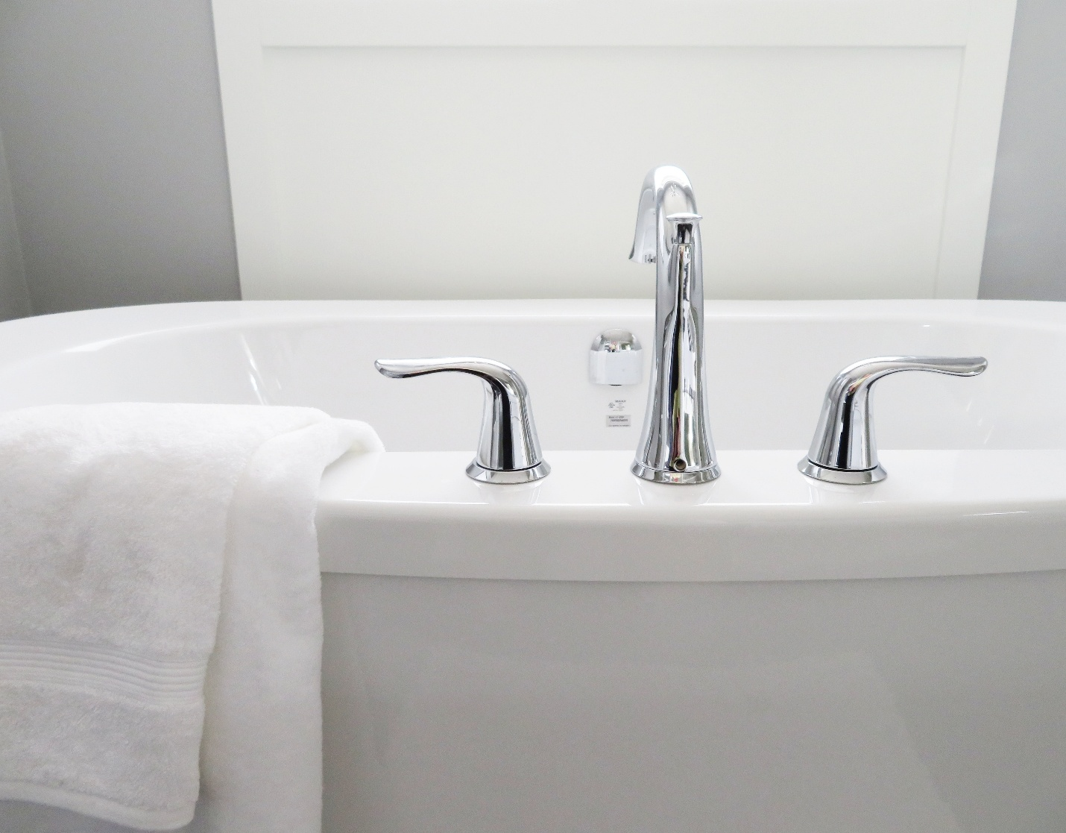
What is Lodgify?
Lodgify is an intelligent website building platform that allows rental vacation businesses to make their own customized websites with ease and speed. This software has a complete set of features which can help you create an efficient vacation website that attracts travelers.
Lodgify makes it easier for hotels and rental lodge owners to cater to their customer needs who might be booking their spots from a different time and space. It is a complete software solution so it takes care of the financial aspect of your business as well.
Having been in the business for nearly five years now, Lodgify has served a great number of customers who are mainly from the vacation rental industry. It’s efficiency is something that attracts most customers.

Overview of Lodgify Benefits

To make website designing easier for you, Lodgify has more than 30 ready to use website designs which you can instantly get started with. These templates have been designed by professionals and therefore it makes sure that you convert most of your visitors into customers.
Depending on the type of business you own, Lodgify can scale accordingly. If you have a rental vacation service or a professional multi-property business, Lodgify has a single platform solution for all. It keeps all your business information at a place and has an intuitive interface which makes your work a bit more enjoyable.
To make reservation booking simpler, Lodgify offers a unique calendar feature, This feature displays the availability of dates so that your customers know before calling whether there is enough space at your hotel.
The website is highly customizable and so you can create a completely unique home page. You can add your logo, colors, themes and fonts. All of it is done through just a few clicks so you don’t really need to be a tech expert for your website customization.
To let you expand and give you maximum opportunities to book customers, Lodgify is available in several languages. This helps you to provide personalized experience to your visitors which can turn out to be a fruitful investment.

Overview of Lodgify Features
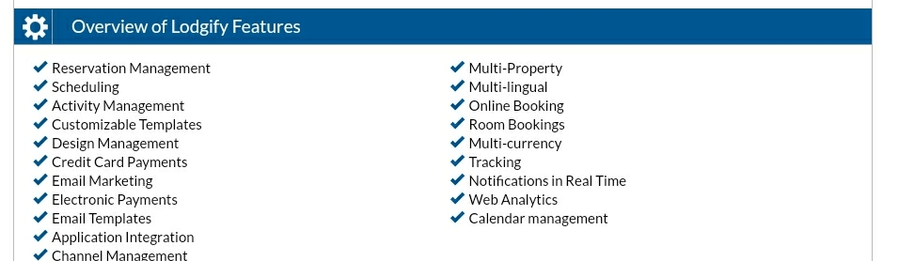

Reservation Management
Scheduling
Activity Management
Customizable Templates
Design Management
Credit Card Payments
Email Marketing
Electronic Payments
Email Templates
Application Integration
Channel Management
Multi-Property
Multi-lingual
Online Booking
Room Bookings
Multi-currency
Tracking
Notifications in Real Time
Web Analytics
Calendar management

Review
Users can choose from a variety of website templates that are mobile-friendly and customizable. The “Book Now” feature enables owners to accept online bookings and credit card payment from one dashboard. The channel manager allows users to keep calendar availability, photos, and information in sync with other listings sites including AirBnB, Booking.com, and Homeaway. The reservation system receives all inquiries in one inbox, allowing the user to manage requests and bookings from one place.
Individual websites link to social media pages and feature “like” and “share” buttons. The design themes are available in 22 languages through a translation tool.

